Roll No.: C-147 | Name: Saumya Sura
Program: BTI | Batch: D-1
Date of Experiment: 20/2/26 | Date of Submission: 20/2/26

EXPERIMENT NO. 4

Aim: To study concept of access modifiers, packages, introduction to string & string buffer Class.

Learning Outcomes: Learner would be able to
- Understand the access modifiers and packages
- Understand the string and string buffer constructs

Theory:
- In Java, Access modifiers help to restrict the scope of a class, constructor, variable, method, or data member. It provides security, accessibility, etc. to the user depending upon the access modifier used with the element. In this article, let us learn about Java Access Modifiers, their types, and the uses of access modifiers.

Types of Access Modifiers:

There are 4 types of access modifiers available in Java:
  - Default – No keyword required
  - Private
  - Protected
  - Public

Modifier | Same Class | Same Package | Subclass | Outside Package
private | ✔ | ✖ | ✖ | ✖
default | ✔ | ✔ | ✖ | ✖
protected | ✔ | ✔ | ✔ | ✖
public | ✔ | ✔ | ✔ | ✔

- Packages in Java are a mechanism that encapsulates a group of classes, sub-packages, and interfaces.
Packages are used for:
- Prevent naming conflicts by allowing classes with the same name to exist in different packages,
like college.staff.cse.Employee and college.staff.ee.Employee.
- They make it easier to organize, locate, and use classes, interfaces, and other components.
- Packages also provide controlled access for Protected members that are accessible within the same package and by subclasses.
- Also, for default members (no access specifier) that are accessible only within the same package.

By grouping related classes into packages, Java promotes data encapsulation, making code reusable and easier to manage. Simply import the desired class from a package to use it in your program.

Working of Java Packages:

Directory Structure: Package names and directory structures are closely related. For example, if a package name is college.staff.cse, then three directories are college, staff, and cse, where cse is inside staff, and staff is inside the college.

Naming Conventions: Package names are written in reverse order of domain names, e.g., org.geeksforgeeks.practice.

In a college, the convention might be: college.tech.cse college.tech.ee college.art.history

Example: import java.util.*;

Types of Java Packages

- Built-in Packages :

These packages consist of a large number of classes which are a part of Java API. Some of the commonly used built-in packages are:
java.lang: Contains language support classes(e.g classes which defines primitive data types, math operations). This package is automatically imported.

java.io: Contains classes for supporting input / output operations.

java.util: Contains utility classes which implement data structures like Linked List, Dictionary and support; for Date / Time operations.

java.applet: Contains classes for creating Applets.

java.awt: Contain classes for implementing the components for graphical user interfaces (like button , ;menus etc.).

java.net: Contain classes for supporting networking operations.

User-defined Packages:

These are the packages that are defined by the user. First, we create a directory myPackage (name should be same as the name of the package). Then create the MyClass inside the directory with the first statement being the package names.

- A String in Java is a sequence of characters that can be used to store and manipulate text data and It is basically an array of characters that are stored in a sequence of memory locations. All the strings in Java are immutable in nature, i.e. once the string is created we can’t change it. This article provides a variety of programs on strings, that are frequently asked in the technical round in various software engineering interviews including various operations such as reversing, Iteration, palindrome, swapping, and splitting of strings etc. The characteristics of String class are:

- String objects are immutable
- Once created, content cannot be changed

Stored in String Constant Pool Common methods include:

Method call | Task performed
s2=s1.tolowerCase; | Convert the string to all lowercase
s2=s1.toupperCase; | Convert the string to all uppercase
s2=s1.replace(‘x’,’y’); | Replace all appearances of x with y
s2=s1.trim(); | Remove white spaces at the beginning and end of the string s1
s1.equals(s2); | Return true if s1=s2
s1.equalsIgnoreCase(s2) | Return true if s1=s2, ignoring the case of characters
s1.length() | Gives the length of s1
s1.CharAt(n) | Gives n th character of s1
s1.compareTo(s2) | Returns negative if s1<s2,positive if s1>s2 and zero if s1=s2
s1.concat(s2) | Concatenates s1 and s2
S1.substring(n) | Gives substring starting from n th character
S1.substring(n,m) | Gives substring starting from n th character up to m th(excluding m th character)
p.toString() | Creates a string representation of object p
S1.indexOf(‘x’) | Gives the position of the first occurrence of ‘x’ in the string s1
S1.indexOf(‘x’,n) | Gives the position of of ‘x’ that occurs after nth position in the string s1
String.ValueOf(variable) | Converts the parameter value to string representation(converts int, float etc into string)

- StringBuffer is a class in Java that represents a mutable sequence of characters. It provides an alternative to the immutable String class, allowing you to modify the contents of a string without creating a new object every time.

Features of StringBuffer Class

Here are some important features and methods of the StringBuffer class:

- StringBuffer objects are mutable, meaning that you can change the contents of the buffer without creating a new object.
- The initial capacity of a StringBuffer can be specified when it is created, or it can be set later with the ensureCapacity() method.
- The append () method is used to add characters, strings, or other objects to the end of the buffer.
- The insert () method is used to insert characters, strings, or other objects at a specified position in the buffer.
- The delete () method is used to remove characters from the buffer.
- The reverse () method is used to reverse the order of the characters in the buffer.
- For the following Problem Statements write programs using classes, objects and methods

Common methods include:

Method | Task
s1.setCharAt(n,’x’) | Modifies the n^{th} character of x
s1.append(s2) | Appends the string s2 to s1 at the end
s1.insert(n,s2) | Insert the string s2 at the position n of the string s1
s1.setLength(n) | If n>s1.length() zeros are added to s1.

Programming Examples:

Program 1: Access Modifiers Example
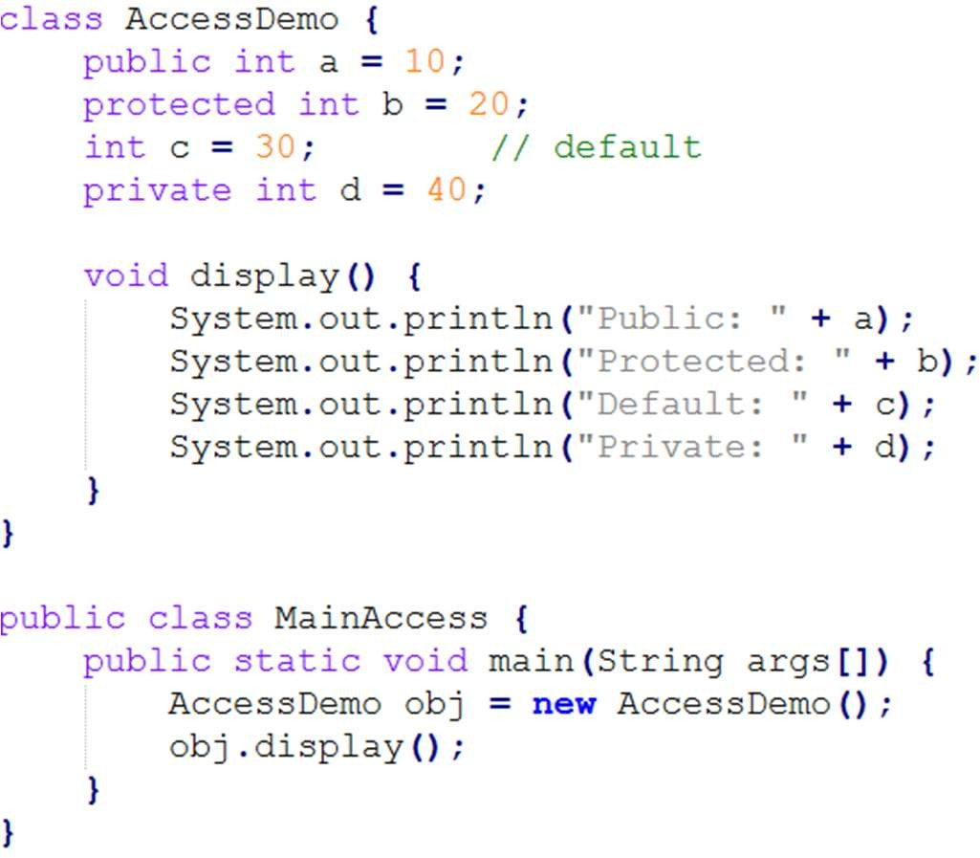

Program 2: User-Defined Package

File: MyPackageDemo.java
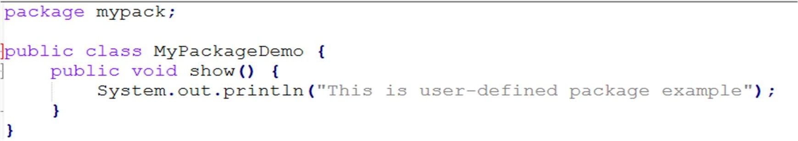

File: MainPackage.java
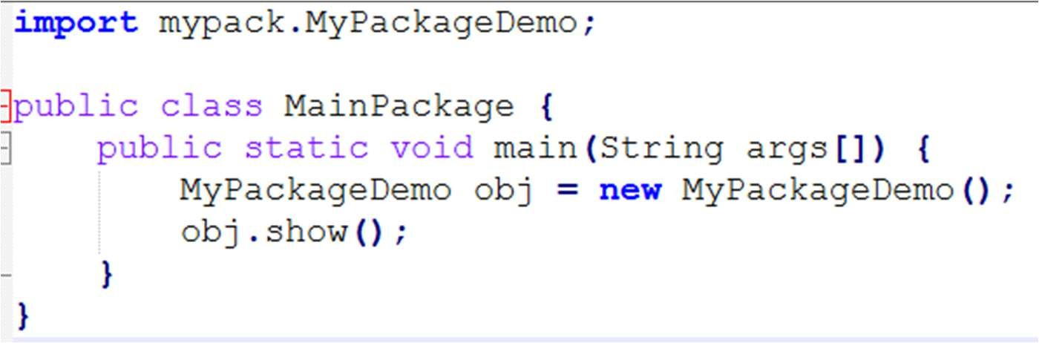

Program 3: String Class Example
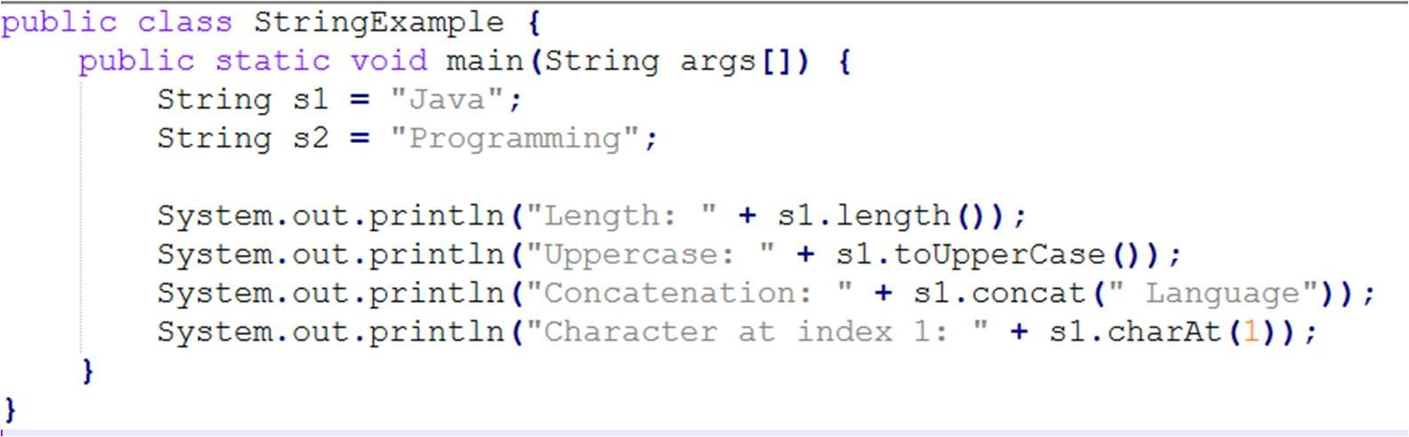

Program 4: StringBuffer Example
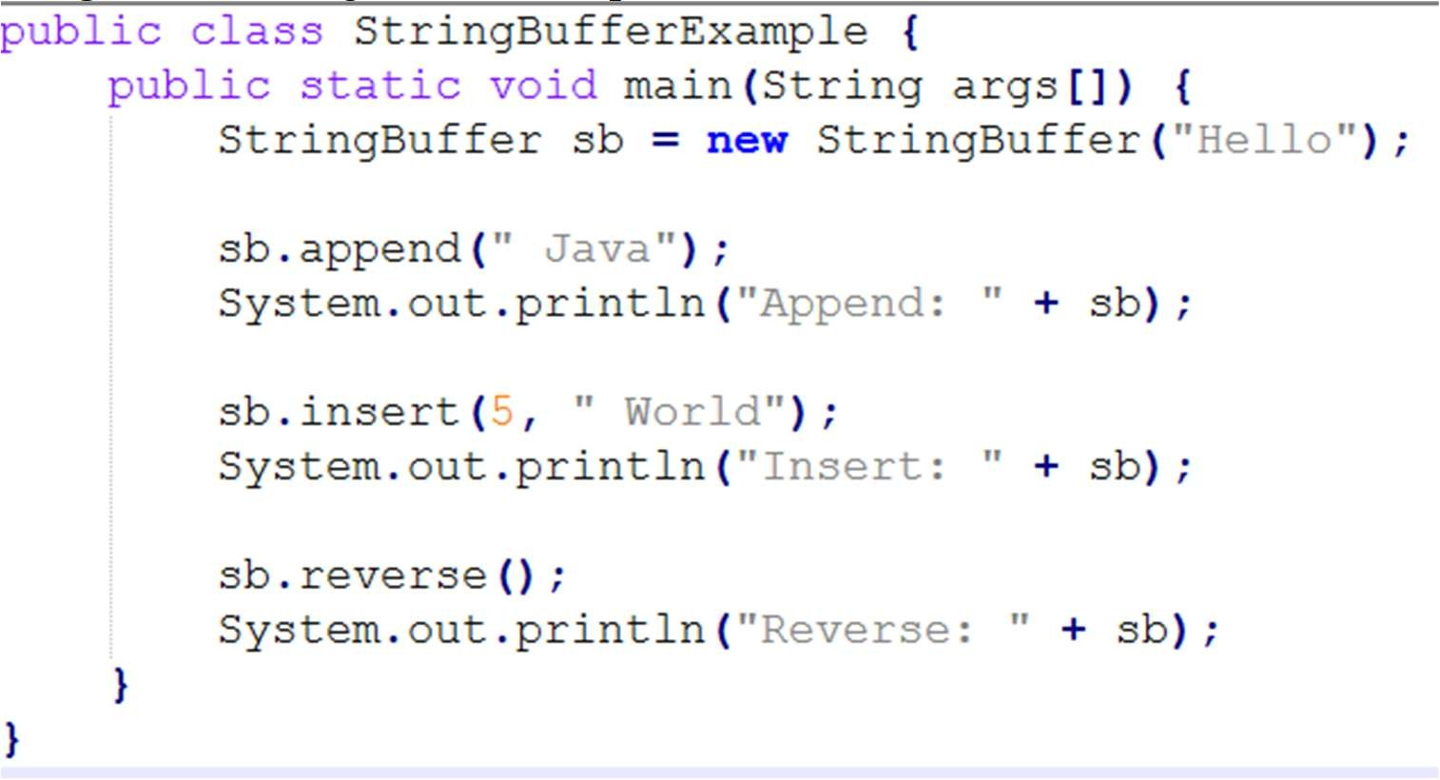

Post Lab questions:
  - Write a Java program to access class members using different access modifiers within the same class.
  - Write a Java program to show how packages help in code reusability.
  - Write a Java program to compare two strings using equals() method.
  - Write a program to append, insert, and reverse a string using StringBuffer.
  - Write a Java program to differentiate between String and StringBuffer.

To be done by students in lab file:

- WAP to perform employee payroll processing using packages. In the java file, Emp.java creates a package employee and creates a class Emp. Declare the variables name, emp_id, category, basic_pay, hra, da, net_pay, PF, gross_pay, income_tax, and allowance. Calculate the values in methods. Create another java file Emppay.java. Create an object e to call the methods to perform and print values.
- Develop an Employee Attendance Management System using Java packages. Create a package attendance and define a class EmployeeAttendance in EmployeeAttendance.java. Declare variables such as name, empID, totalWorkingDays, daysPresent, daysAbsent, and attendancePercentage. Implement methods to calculate attendance percentage and display attendance records. In another file AttendanceReport.java, create an object, input attendance details, compute the percentage, and print the attendance summary.

- Create a Student Management System with a package university and the following requirements:

  - Class Student (inside university package)
    - Private attributes: name, roll_no, course, marks[]
    - Methods to calculate total marks, percentage, and grade
  - Class Result (in the same package)
    - Inherits Student
    - Can access marks and calculate grade
  - Class StudentPortal (in another package portal)
    - Tries to access student details (but can't access private data)

- Develop a Vehicle Rental System with a package rental and the following requirements:

  - Class Vehicle (inside rental package)
    - Private attributes: vehicleNumber, model, rentalRate
    - Protected method calculateRental(int days)
  - Class Car & Bike (same package, inherit Vehicle)
    - Override rental calculation based on type
  - Class Customer (in another package customer)

    - Can only rent vehicles (not modify rental rates directly)

- Develop a password masking system that replaces characters with * using
StringBuffer.replace().

  - Take password input.
  - Replace characters with *.

Example:

  - Input: "mypassword"
  - Output: "**********"

- Create a program to check whether a given string is a palindrome (same when reversed). Use StringBuffer.reverse() for checking.

  - Convert input into lowercase.
  - Remove spaces and special characters (optional).
  - Reverse the string using reverse().
  - Compare with the original string.

Executed Code, Input and Output:
1. | Write the question here.
Executed Code: -
// Paste the executed code here
1)
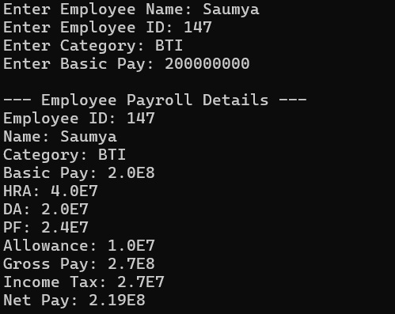

2)
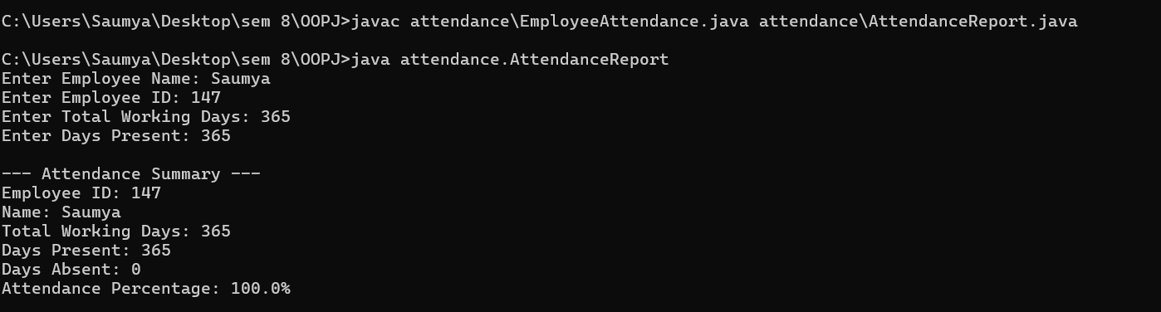
3)
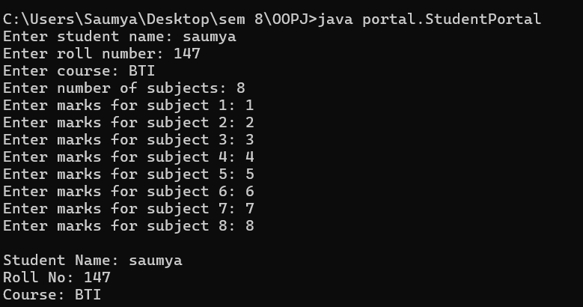
4)
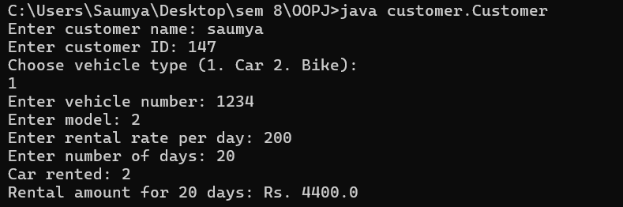
5)
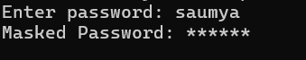
6)
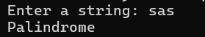

Input Output: -
// Paste the input/output of executed code
1) package employee;

public class Emp {
public String name;
public int emp_id;
public String category;
public double basic_pay, hra, da, net_pay, pf, gross_pay, income_tax, allowance;

public Emp(String name, int emp_id, String category, double basic_pay) {
this.name = name;
this.emp_id = emp_id;
this.category = category;
this.basic_pay = basic_pay;
calculate();
}

private void calculate() {
hra = 0.2 * basic_pay;
da = 0.1 * basic_pay;
pf = 0.12 * basic_pay;
allowance = 0.05 * basic_pay;
gross_pay = basic_pay + hra + da + allowance;
income_tax = 0.1 * gross_pay;
net_pay = gross_pay - (pf + income_tax);
}

public void printDetails() {
System.out.println("Employee ID: " + emp_id);
System.out.println("Name: " + name);
System.out.println("Category: " + category);
System.out.println("Basic Pay: " + basic_pay);
System.out.println("HRA: " + hra);
System.out.println("DA: " + da);
System.out.println("PF: " + pf);
System.out.println("Allowance: " + allowance);
System.out.println("Gross Pay: " + gross_pay);
System.out.println("Income Tax: " + income_tax);
System.out.println("Net Pay: " + net_pay);
}
}
Emp pay:
package employee;

import java.util.Scanner;

public class Emppay {
public static void main(String[] args) {
Scanner sc = new Scanner(System.in);
System.out.print("Enter Employee Name: ");
String name = sc.nextLine();
System.out.print("Enter Employee ID: ");
int emp_id = sc.nextInt();
sc.nextLine(); // consume newline
System.out.print("Enter Category: ");
String category = sc.nextLine();
System.out.print("Enter Basic Pay: ");
double basic_pay = sc.nextDouble();
Emp e = new Emp(name, emp_id, category, basic_pay);
System.out.println("\n--- Employee Payroll Details ---");
e.printDetails();
sc.close();
}
}
2)
Attendance report:
package attendance;
import java.util.Scanner;
public class AttendanceReport {
public static void main(String[] args) {
Scanner sc = new Scanner(System.in);
System.out.print("Enter Employee Name: ");
String name = sc.nextLine();
System.out.print("Enter Employee ID: ");
int empID = sc.nextInt();
System.out.print("Enter Total Working Days: ");
int totalWorkingDays = sc.nextInt();
System.out.print("Enter Days Present: ");
int daysPresent = sc.nextInt();
EmployeeAttendance ea = new EmployeeAttendance(name, empID, totalWorkingDays, daysPresent);
System.out.println("\n--- Attendance Summary ---");
ea.displayAttendance();
sc.close();
}
}
Main code:
package attendance;

public class EmployeeAttendance {
public String name;
public int empID;
public int totalWorkingDays;
public int daysPresent;
public int daysAbsent;
public double attendancePercentage;

public EmployeeAttendance(String name, int empID, int totalWorkingDays, int daysPresent) {
this.name = name;
this.empID = empID;
this.totalWorkingDays = totalWorkingDays;
this.daysPresent = daysPresent;
this.daysAbsent = totalWorkingDays - daysPresent;
calculatePercentage();
}

public void calculatePercentage() {
if (totalWorkingDays > 0) {
attendancePercentage = (daysPresent * 100.0) / totalWorkingDays;
} else {
attendancePercentage = 0;
}
}

public void displayAttendance() {
System.out.println("Employee ID: " + empID);
System.out.println("Name: " + name);
System.out.println("Total Working Days: " + totalWorkingDays);
System.out.println("Days Present: " + daysPresent);
System.out.println("Days Absent: " + daysAbsent);
System.out.println("Attendance Percentage: " + attendancePercentage + "%");
}
}

3)
Student :
package university;

public class Student {
private String name;
private int roll_no;
private String course;
private int[] marks;

public Student(String name, int roll_no, String course, int[] marks) {
this.name = name;
this.roll_no = roll_no;
this.course = course;
this.marks = marks;
}

public int getTotalMarks() {
int total = 0;
for (int m : marks) total += m;
return total;
}

public double getPercentage() {
return (getTotalMarks() / (marks.length * 100.0)) * 100;
}

public String getGrade() {
double percent = getPercentage();
if (percent >= 90) return "A";
else if (percent >= 75) return "B";
else if (percent >= 60) return "C";
else if (percent >= 40) return "D";
else return "F";
}

// Getters for StudentPortal (not private data)
public String getName() { return name; }
public int getRollNo() { return roll_no; }
public String getCourse() { return course; }
}
Result:
package university;

public class Result extends Student {
public Result(String name, int roll_no, String course, int[] marks) {
super(name, roll_no, course, marks);
}

public void displayResult() {
System.out.println("Name: " + getName());
System.out.println("Roll No: " + getRollNo());
System.out.println("Course: " + getCourse());
System.out.println("Total Marks: " + getTotalMarks());
System.out.println("Percentage: " + getPercentage());
System.out.println("Grade: " + getGrade());
}
}

Portal:
package portal;
import university.Student;
import java.util.Scanner;

public class StudentPortal {
public static void main(String[] args) {
Scanner sc = new Scanner(System.in);
System.out.print("Enter student name: ");
String name = sc.nextLine();
System.out.print("Enter roll number: ");
int rollNo = sc.nextInt();
sc.nextLine(); // consume newline
System.out.print("Enter course: ");
String course = sc.nextLine();
System.out.print("Enter number of subjects: ");
int n = sc.nextInt();
int[] marks = new int[n];
for (int i = 0; i < n; i++) {
System.out.print("Enter marks for subject " + (i+1) + ": ");
marks[i] = sc.nextInt();
}
Student s = new Student(name, rollNo, course, marks);
System.out.println("\nStudent Name: " + s.getName());
System.out.println("Roll No: " + s.getRollNo());
System.out.println("Course: " + s.getCourse());
// The following lines would cause error if uncommented:
// System.out.println(s.marks); // Not accessible
// System.out.println(s.name); // Not accessible
sc.close();
}
}
4) package customer;
import rental.*;
import java.util.Scanner;

public class Customer {
private String name;
private String customerId;

public Customer(String name, String customerId) {
this.name = name;
this.customerId = customerId;
}

public void rentVehicle(Vehicle v, int days) {
double amount = 0;
if (v instanceof Car) {
amount = ((Car)v).calculateRental(days);
System.out.println("Car rented: " + v.getModel());
} else if (v instanceof Bike) {
amount = ((Bike)v).calculateRental(days);
System.out.println("Bike rented: " + v.getModel());
} else {
amount = v.getRentalRate() * days;
System.out.println("Vehicle rented: " + v.getModel());
}
System.out.println("Rental amount for " + days + " days: Rs. " + amount);
}

public static void main(String[] args) {
Scanner sc = new Scanner(System.in);
System.out.print("Enter customer name: ");
String name = sc.nextLine();
System.out.print("Enter customer ID: ");
String id = sc.nextLine();
Customer c = new Customer(name, id);
System.out.println("Choose vehicle type (1. Car 2. Bike): ");
int type = sc.nextInt();
sc.nextLine();
System.out.print("Enter vehicle number: ");
String vno = sc.nextLine();
System.out.print("Enter model: ");
String model = sc.nextLine();
System.out.print("Enter rental rate per day: ");
double rate = sc.nextDouble();
System.out.print("Enter number of days: ");
int days = sc.nextInt();
Vehicle v;
if (type == 1) v = new Car(vno, model, rate);
else v = new Bike(vno, model, rate);
c.rentVehicle(v, days);
sc.close();
}
}
5) import java.util.Scanner;

public class PasswordMask {
public static void main(String[] args) {
Scanner sc = new Scanner(System.in);
System.out.print("Enter password: ");
String password = sc.nextLine();
StringBuffer masked = new StringBuffer(password);
for (int i = 0; i < masked.length(); i++) {
masked.replace(i, i+1, "*");
}
System.out.println("Masked Password: " + masked);
sc.close();
}
}
6)
import java.util.Scanner;

public class PalindromeCheck {
public static void main(String[] args) {
Scanner sc = new Scanner(System.in);
System.out.print("Enter a string: ");
String input = sc.nextLine();
// Convert to lowercase and remove non-alphanumeric characters
String cleaned = input.toLowerCase().replaceAll("[^a-z0-9]", "");
StringBuffer sb = new StringBuffer(cleaned);
String reversed = new StringBuffer(cleaned).reverse().toString();
if (cleaned.equals(reversed)) {
System.out.println("Palindrome");
} else {
System.out.println("Not a palindrome");
}
sc.close();
}
}

